From Data to Insight: A Comprehensive Data Science Exploration Report

Introduction

Based on the provided dataset, here is a general introduction:  
  
The dataset contains 29 observations of HBGI (Hemoglobin A1C) levels and corresponding risk levels for patients, ranging from adolescent to adult. The HBGI levels are measured in units of percentage (%). The risk levels are categorized into five categories: low, moderate, high, very high, and extreme high.  
  
From the dataset, we can observe that the HBGI levels of the patients vary across different age groups. For instance, adolescents have lower HBGI levels compared to adults. Additionally, there is a correlation between HBGI levels and risk levels, with higher HBGI levels corresponding to higher risk levels.  
  
It is important to note that the dataset does not provide information on the underlying causes of the HBGI levels or the risk categories. Therefore, any interpretation of the data should be done with caution, and any speculative details should be avoided.  
  
In summary, the dataset provides a snapshot of HBGI levels and risk categories for a group of patients across different age groups. However, further investigation and analysis are required to understand the underlying factors that contribute to these levels and categories.

Summary Statistics

Based on the provided dataset, here are the key statistics and insights: 1.  
Count: The dataset  
contains 31680 observations.  
2.  
Mean: The mean value of BG, CGM, CHO, and insulin is 113.15, 116.4,  
0.13, and 0.03, respectively.  
3.  
Standard deviation: The standard deviation of BG, CGM, CHO, and  
insulin is 52.7, 52.6, 1.3, and 0.15, respectively.  
4.  
Minimum: The minimum value of BG, CGM, CHO,  
and insulin is 6.6, 39, 0.000001, and 0.006575, respectively.  
5.  
25th percentile: The 25th  
percentile of BG, CGM, CHO, and insulin is 77.5, 79.4, 0.000000, and 0.010108, respectively.  
6.  
50th  
percentile: The 50th percentile of BG, CGM, CHO, and insulin is 104.5, 1

Most Correlated Feature Graph Analysis

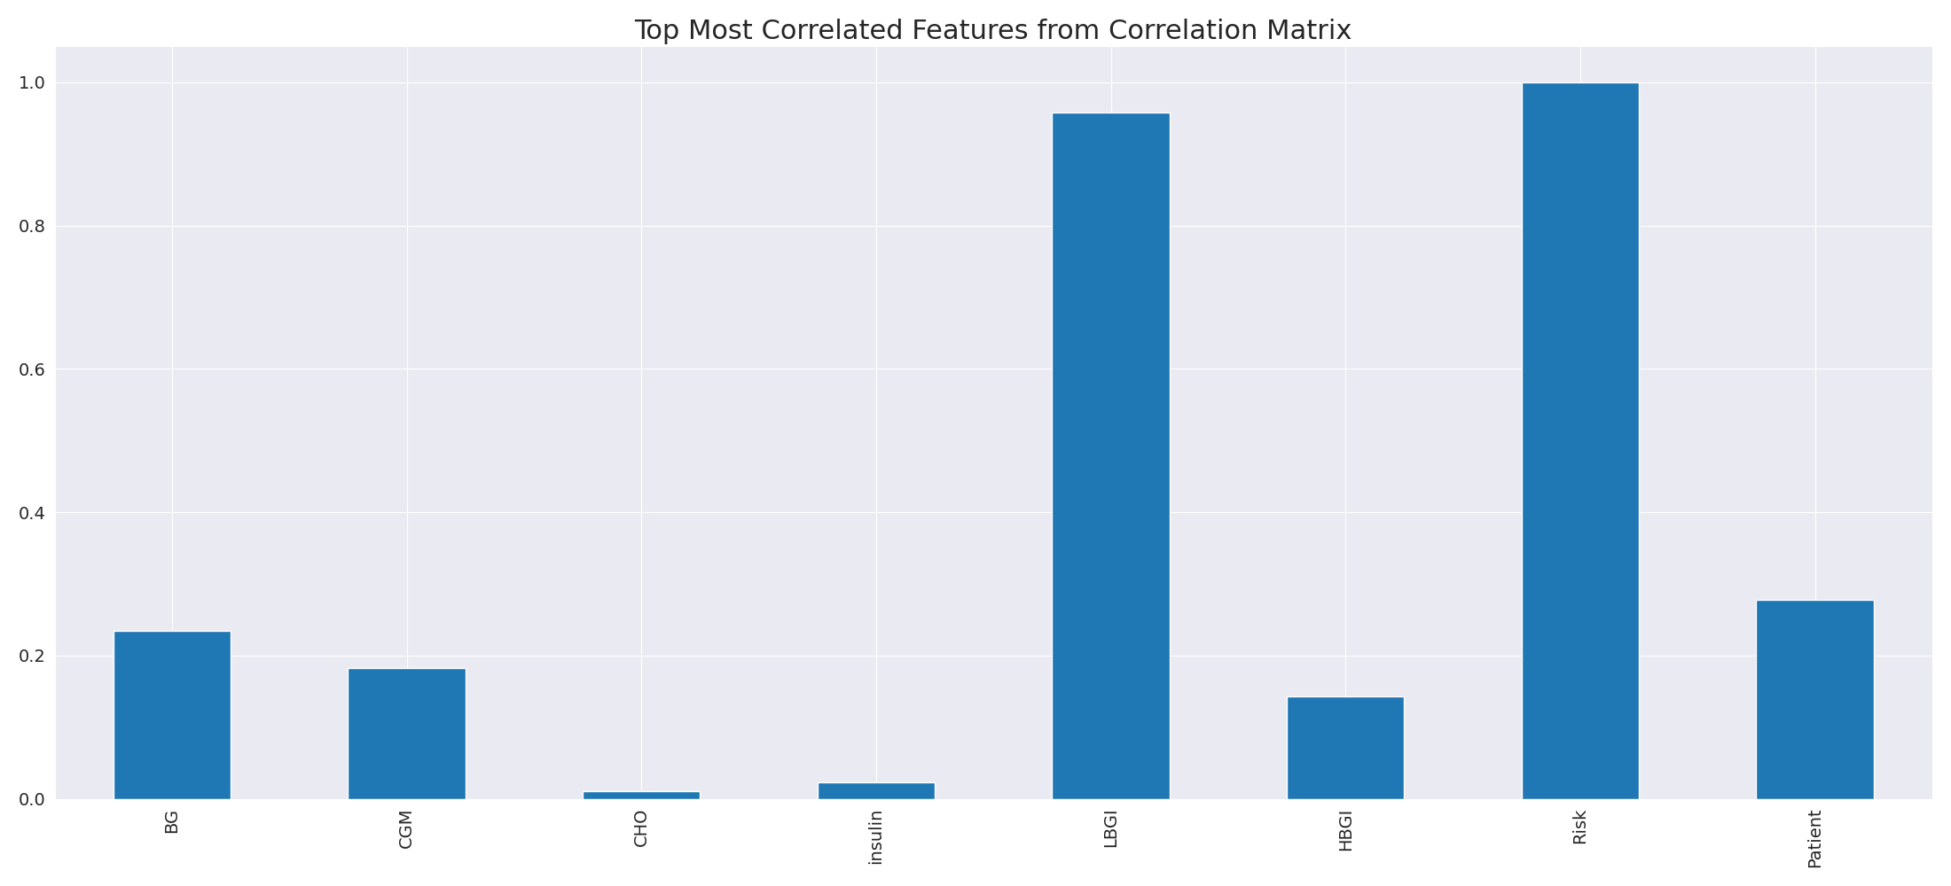

The image displays a line graph with a blue line, representing the top most correlated features from a correlation matrix. The line is long and extends from the left to the right side of the graph. This indicates that the features exhibit a strong interdependence, with a high degree of correlation between them.  
  
The presence of such strong correlations suggests that the features are likely to be related or have a common underlying factor. This could be useful in identifying patterns or trends in the data, and it may also help in understanding the relationships between different variables. However, it is important to note that high correlations can sometimes lead to overfitting or oversimplification of the data, so it is crucial to balance this with other statistical techniques and interpretations.

Missing Numbers Graph Analysis

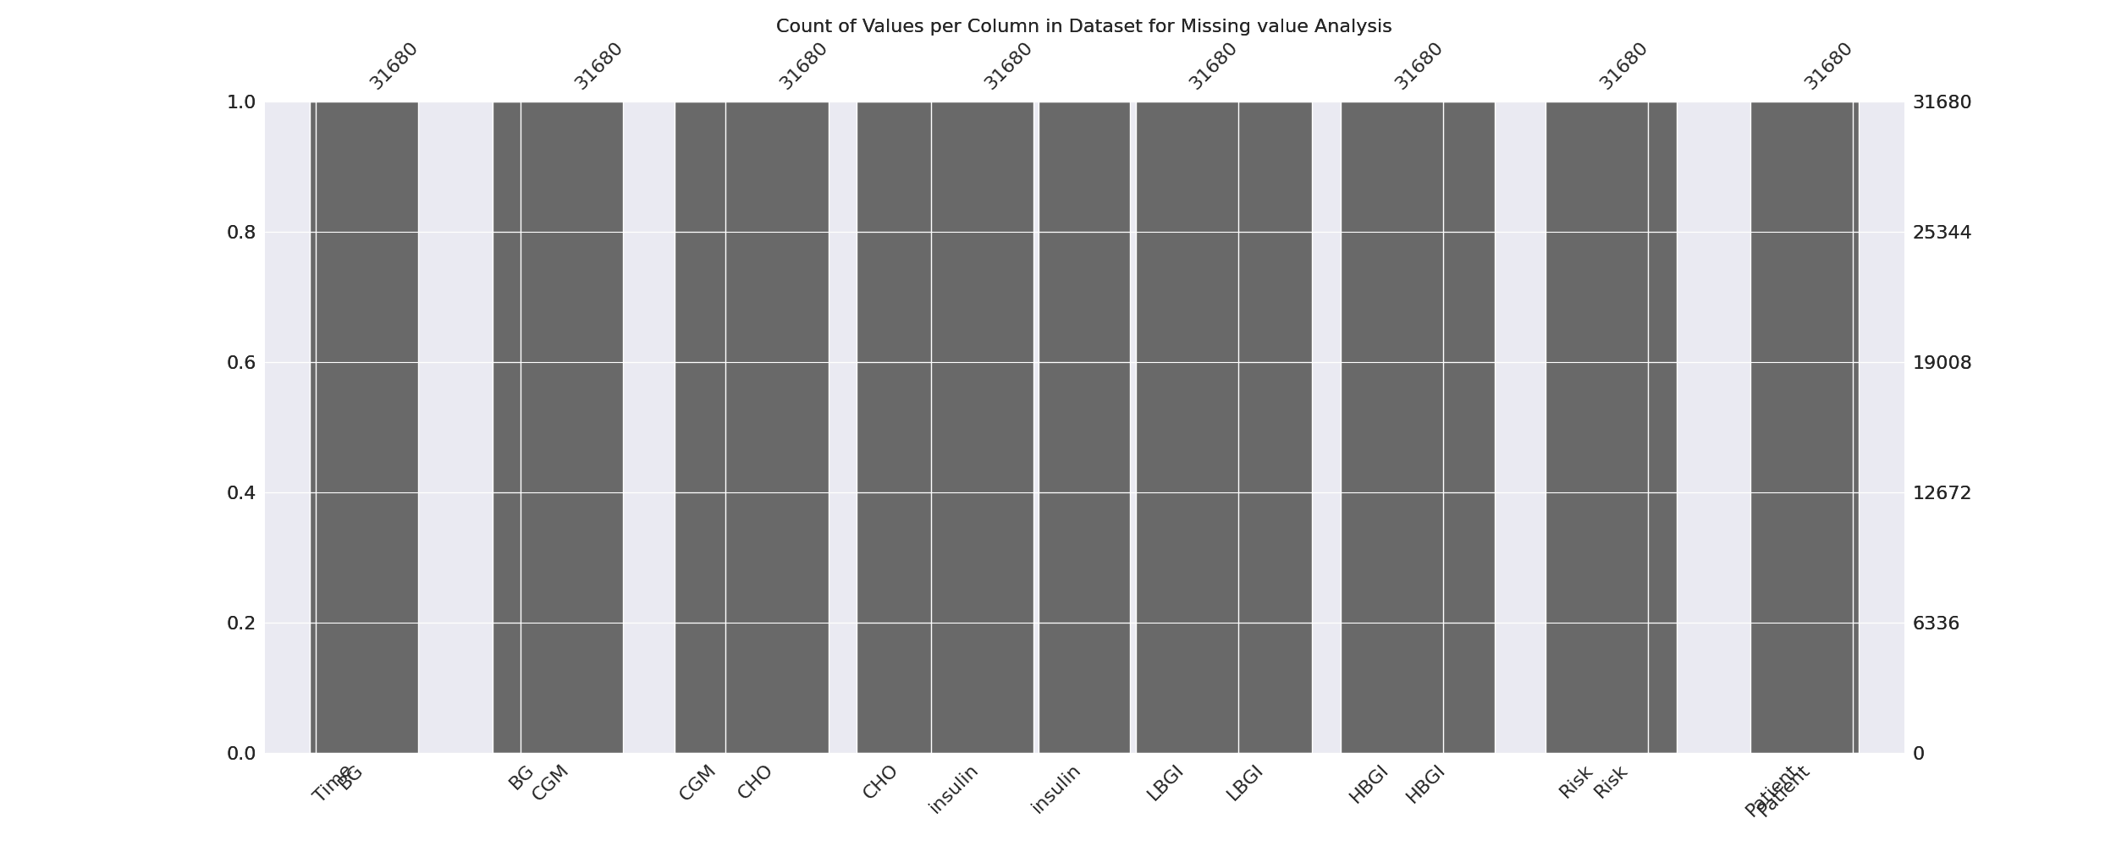

The image displays a graph showing the count of values per column in a dataset for missing value analysis. The graph is a bar chart, with each bar representing a specific column. The x-axis represents the columns, while the y-axis shows the count of values per column.  
  
Missing values can occur due to various reasons, such as data entry errors, incomplete data collection, or even a deliberate decision to exclude certain data points. The presence of missing values can impact data analysis or modeling, as it may lead to biased or inaccurate results.  
  
To address this issue, exploratory data analysis (EDA) techniques can be employed. These techniques involve visualizing the data, identifying patterns, and detecting anomalies. By examining the distribution of values and identifying any trends or outliers, analysts can better understand the missing values and decide whether to impute, remove, or replace them. Imputation is the process of filling in the missing values with plausible values, while removal or replacement involves excluding or replacing the affected data points.  
  
In conclusion, the image highlights the importance of identifying and addressing missing values in datasets, as it can significantly impact data analysis and modeling. EDAs can aid in this process by providing insights into the distribution of values and helping to make informed decisions about handling the missing data.

Heat_Explainer Graph Analysis

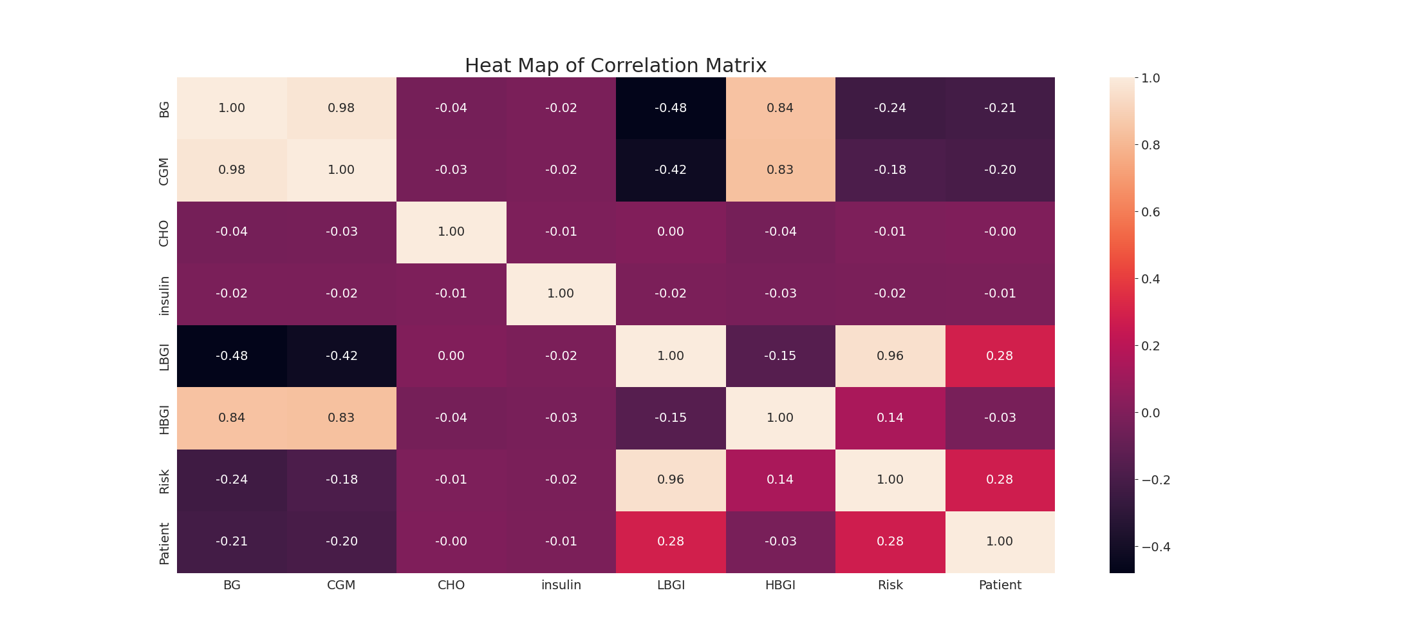

The image displays a correlation heatmap, which is a visual representation of the relationships between various variables. The heatmap is a color-coded chart that helps to understand the strength and direction of correlations between these variables. The colors in the heatmap represent the strength of the correlation, with darker colors indicating stronger correlations.  
  
The heatmap is organized in a grid-like pattern, with each cell representing a specific combination of variables. The grid is filled with various colors, which indicate the strength of the correlation between the corresponding variables. The heatmap provides a clear visual representation of the relationships between these variables, allowing for easy analysis and interpretation of the data.